关于面向中国大陆地区考生
提供汉语水平诊断分析及成绩报告寄送服务的通知
受新型冠状病毒疫情影响，为防止疫情扩散，保障考生生命安全和身体健康，满足考生入学申请、诊断分析汉语水平、提升汉语能力等需求，即日起汉考国际向考生提供汉语水平诊断分析和成绩报告指定寄送服务。2020年1月1日后，在中国大陆地区参加汉语考试的考生均可在普通纸质成绩报告基础上，额外获得一份汉语水平分析报告，同时可申请将诊断分析及成绩报告直接邮寄至指定地址。成绩报告中国国内邮寄和汉语水平诊断分析服务费为80元人民币（疫情期间按60元收取），国外服务费将根据快递服务商各国邮寄服务费和汉语水平诊断分析服务费标准收取。考生可在线填写指定地址，申请诊断分析和成绩报告寄送服务，具体方式如下：
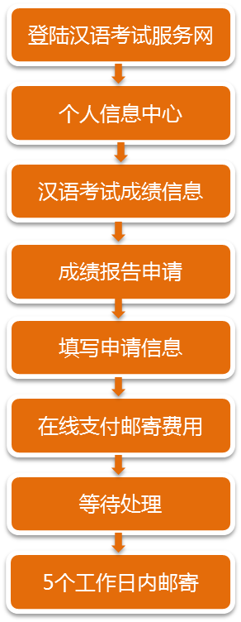

汉考国际
2020年3月24日

NNotice on Providing Analysis of the Chinese Proficiency and the Score Report Delivery Service to the Test Takers within China

Affected by the new coronavirus, in order to limit the spread of the epidemic, to ensure the safety and health of every test taker, and to satisfy the requirements for admission, the analysis of the Chinese proficiency and the Chinese language skills improvement, CTI will provide the service of analysis of the Chinese proficiency and the delivery of the score report from today. Test taker, from January 1, 2020 within mainland China could also gain an analysis report of the Chinese proficiency, in addition to a paper score report, that could be sent to a given address directly. Service fee for the domestic mailing of the analysis report and the score report is 80RMB/copy (60RMB/copy during the outbreak). Service fee for the overseas mailing will be charged according to the freight tariffs between countries and the service charge standard of the analysis report. Test takers may fill an address online to apply for these two services. The guide is as follow.
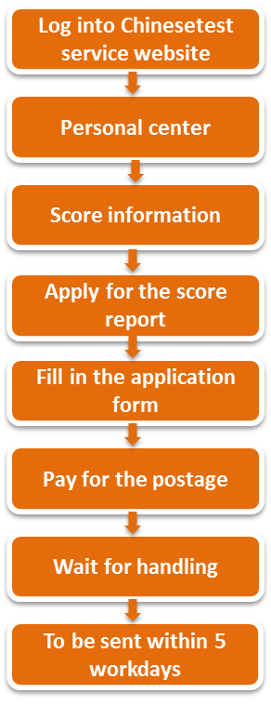
Chinese Testing International
March 24th, 2020

